**Continuous Y – GRAPHICAL METHODS**

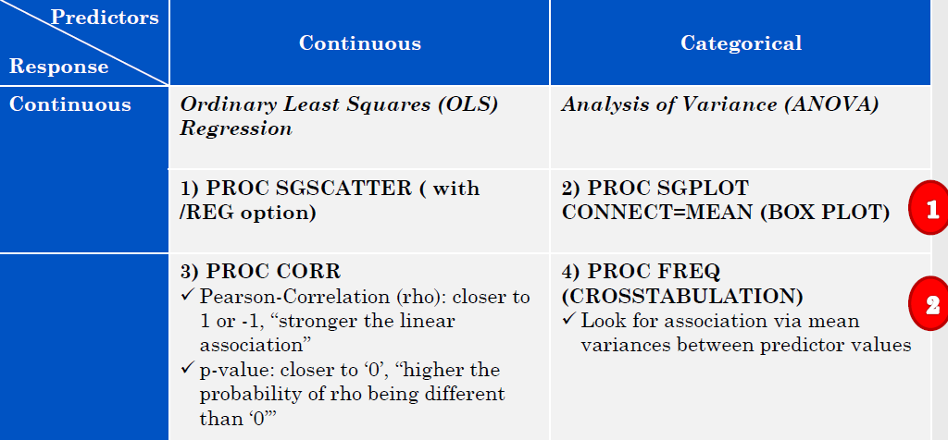

**Continuous Y – MODELING METHODS**

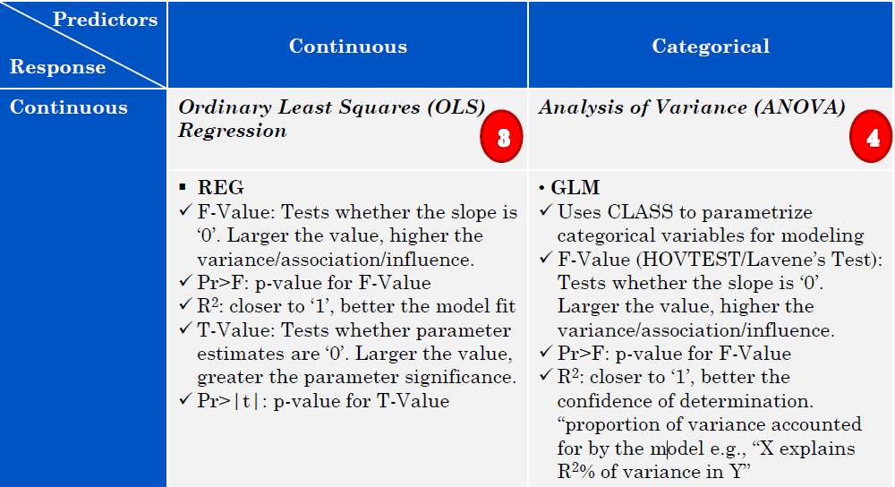

**Model/Metric – Categorical Resp.**

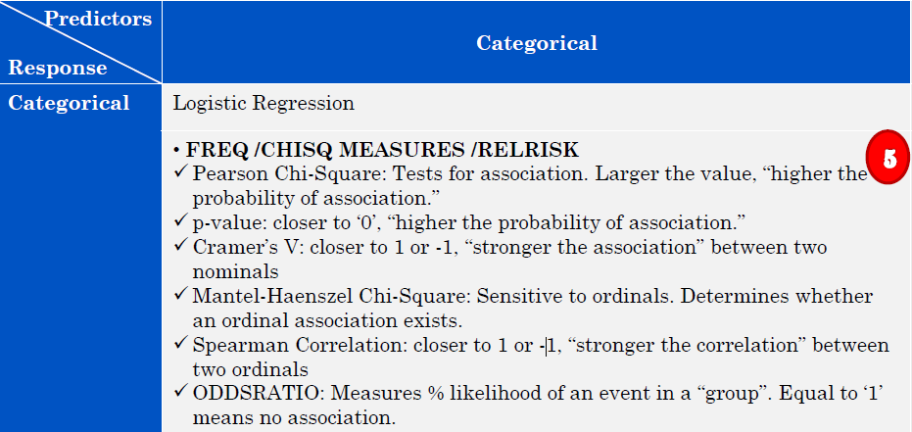

**Model/Metric – Categorical Resp.**